

**Software User’s Guide:**

**VPRINT for Windows**

**Version 1.0.5357**

**VPrint**

**Prepared for:**

**Premier Tax Free (Ltd.) UK**

**Prepared by:**

**Mr. Rosen Rusev**

**Somerset House,**

**47-49 London Rd,**

**Redhill, Surrey**

**RH1 1LU**

**Tel: +44 1737 644922**

**Email:** [**rosen.rusev@uk.premiertaxfree.com**](mailto:rosen.rusev@uk.premiertaxfree.com)

**September 2014**

**ACKNOWLEDGMENTS**

**This VPRINT for Windows upgrade is the result of work performed by Rosen Rusev.**

**TABLE OF CONTENTS**

INTRODUCTION 5

What voucher is? 5

What VPrint is? 5

DIFFERENCES FROM PREVIOUS VERSIONS 5

GETTING STARTED 5

OPERATING SYSTEM REQUIREMENTS 5

If you want to run Windows 7 on your PC, here's what it takes: 5

Additional requirements to use certain features: 5

PCs with multi-core processors 6

PCs with multiple processors (CPUs) 6

INSTALLATION 6

STARTING VPRINT 6

LOG IN THE APPLICATION 6

WHERE ELSE TO GET HELP 7

USING VPRINT 7

APPEARANCE 7

STEP 1: OPERATUING LOCAL SCAN FOLDER 7

OPEN LOCAL SCAN FOLDER 7

STEP 2: OPERATING REMOTE IMAGE STORE 8

OPEN FOLDER 8

How it works? 8

CREATING FODLER 9

How it works? 9

RENAMING FOLDER 10

How it works? 10

Note 10

DELETING FOLDER 10

How it works? 10

Note 10

DELETING ALL FOLDERS 10

How it works? 10

Note 10

STEP 3: OPERATING VOUCHERS 10

SHOWING VOUCHER 10

How it works? 10

SHOWING VOUCHER SIGNED 12

How it works? 12

NAMING VOUCHER 13

How it works? 13

Notes 13

DELETE VOUCHER 13

How it works? 13

Note 14

DELETE ALL VOUCERS IN FOLDER 14

How it works? 14

Notes 15

FORCE SENDING VOUCHER 15

How it works? 15

FORCE SENDING ALL VOUCHERS 15

How it works? 15

IGNORE VOUCHER VALIDATION DURING SEND 15

How it works? 15

Note 15

STEP 4: START SCANNING 15

SCANNING MODES 15

BY BARCODE 15

BY TRANSFER FILE 17

BY SITECODE 19

STEP 5: FILE BROWSING 19

How it works? 19

STEP 6: SCANNING NON VOUCHER IMAGE FILES 20

How it works? 20

STEP 7: MONITORING SCAN PROCESS 21

How it works? 21

STEP 8: SEARCHING FOR A VOUCHER 21

How it works? 21

STEP 9: SHOWING HISTORY 23

How it works? 23

Thank you! 23

# INTRODUCTION

## What voucher is?

Voucher is a copy of a payment document taken from original paper voucher. Voucher may contain many pages or documents attached. It may contain other files as text files, office files, multimedia files, and other image files and so on. It may be either raw, encrypted, signed or credit card covered.

## What VPrint is?

VPrint is a high performance desktop client for scanning vouchers and attached documents.

# DIFFERENCES FROM PREVIOUS VERSIONS

Older scanning system doesn’t support remote image storing. It’s slow and not centralized. It doesn’t support a large variety of scanners and scanning devices.

# GETTING STARTED

## OPERATING SYSTEM REQUIREMENTS

VPrint is Desktop Windows application. In order to run proper it requires following:

### If you want to run Windows 7 on your PC, here's what it takes:

* 1 gigahertz (GHz) or faster 32-bit (x86) or [**64-bit (x64)**](http://windows.microsoft.com/en-gb/windows7/products/features/64-bit-support) processor
* 1 gigabyte (GB) RAM (32-bit) or 2 GB RAM (64-bit)
* 16 GB available hard disk space (32-bit) or 20 GB (64-bit)
* DirectX 9 graphics device with WDDM 1.0 or higher driver

### Additional requirements to use certain features:

* Internet access (fees may apply)
* Depending on resolution, video playback may require additional memory and advanced graphics hardware
* DVD/CD authoring requires a compatible optical drive
* Music and sound require audio output

Product functionality and graphics may vary based on your system configuration. Some features may require an advanced or additional hardware.

PCs with multi-core processors  
Windows 7 was designed to work with today's multi-core processors. All 32-bit versions of Windows 7 can support up to 32 processor cores, while 64‑bit versions can support up to 256 processor cores.

PCs with multiple processors (CPUs)  
Commercial servers, workstations, and other high-end PCs may have more than one physical processor. Windows 7 Professional, Enterprise, and Ultimate allow for two physical processors, providing the best performance on these computers. Windows 7 Starter, Home Basic, and Home Premium will recognize only one physical processor.

## INSTALLATION

To install application locally run installer. You need to run administrative account.

## STARTING VPRINT

Find application icon on your desktop and double click on it.

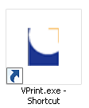

## LOG IN THE APPLICATION

VPrint operates sensitive data. Authenticating user is essential.   
In log in windows enter your TRS credit tails (user name, password and country). Click “Enter”.

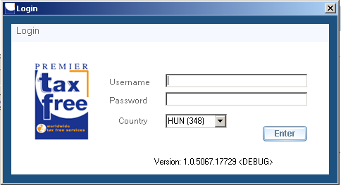

## WHERE ELSE TO GET HELP

To get more help click “Help” menu option in main menu or go to link <https://192.168.53.143/FintraxPTFImages/Help>.

# USING VPRINT

## APPEARANCE

VPrint is a windows forms application. It has got three tabs. To run it, click on and open “Scan” tag. See image.

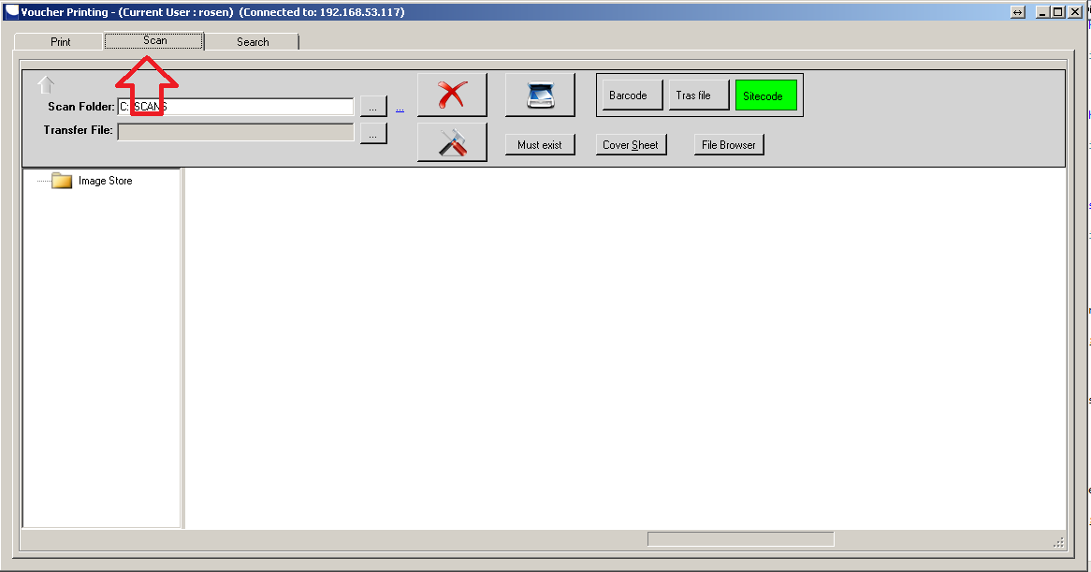

# STEP 1: OPERATUING LOCAL SCAN FOLDER

## OPEN LOCAL SCAN FOLDER

Click on the button next to scan the folder box and browse the folder structure.

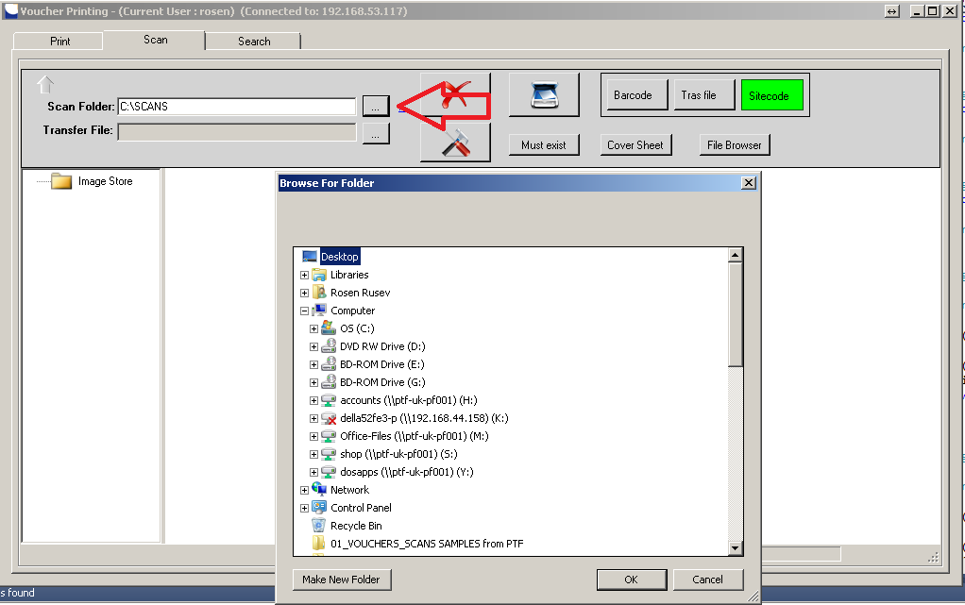

# STEP 2: OPERATING REMOTE IMAGE STORE

## OPEN FOLDER

### How it works?

Click on and open “Image Store folder”. Browse and open folder wanted. Right panel shows vouchers in side.

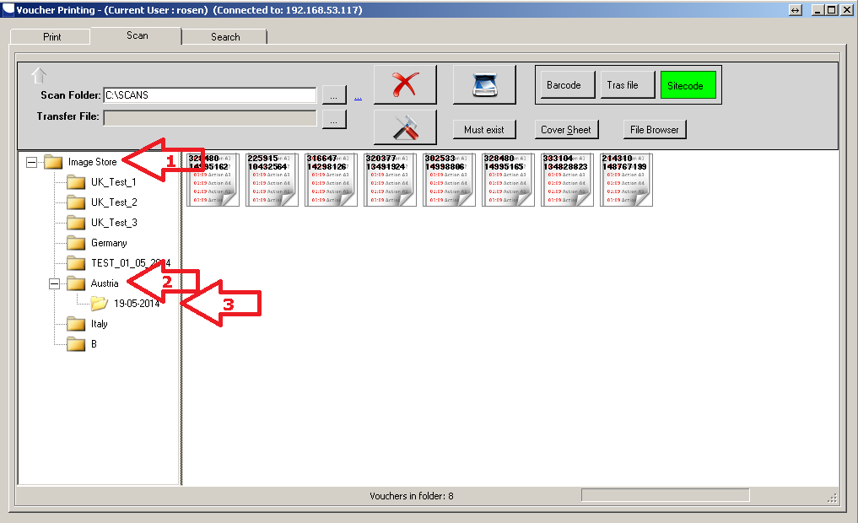

## CREATING FODLER

### How it works?

Right click on node and select “add node” option. Enter the name of the node.

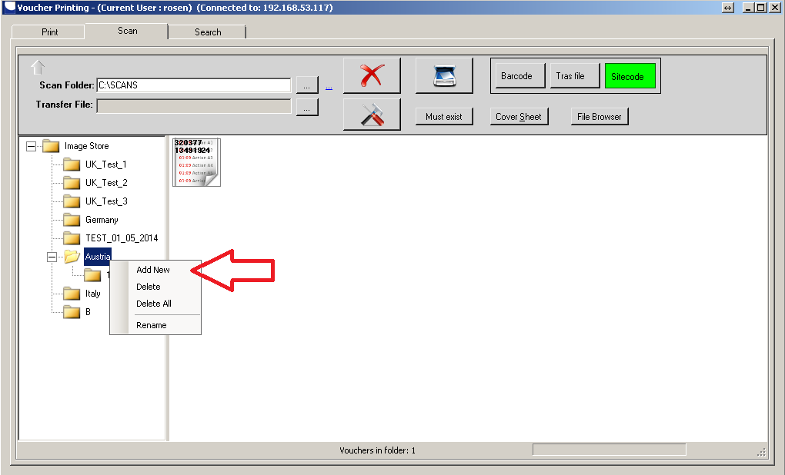

## RENAMING FOLDER

### How it works?

To rename folder use “Rename “menu option.

### Note

Name of the folder may not be longer than 50 characters.

## DELETING FOLDER

### How it works?

Right click on the node wanted; choose “Delete “menu option from context menu.

### Note

Operation cannot be undone.

## DELETING ALL FOLDERS

### How it works?

Right click on any node; choose “Delete All “menu item from context menu.

### Note

Operation cannot be undone.

# STEP 3: OPERATING VOUCHERS

## SHOWING VOUCHER

### How it works?

Point voucher, right click on it, and choose “Show” from drop down context menu.

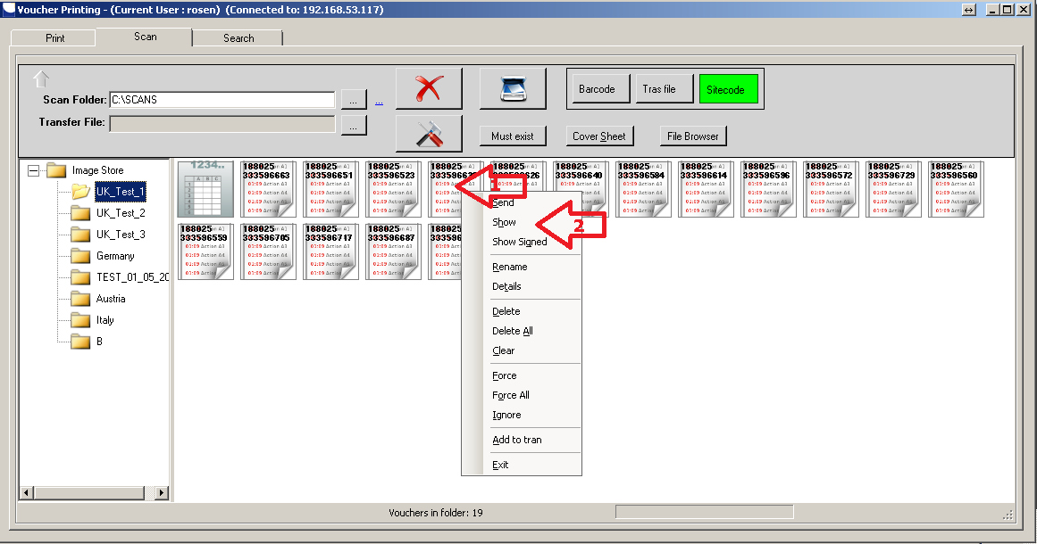

It shows window contacting list of included files.

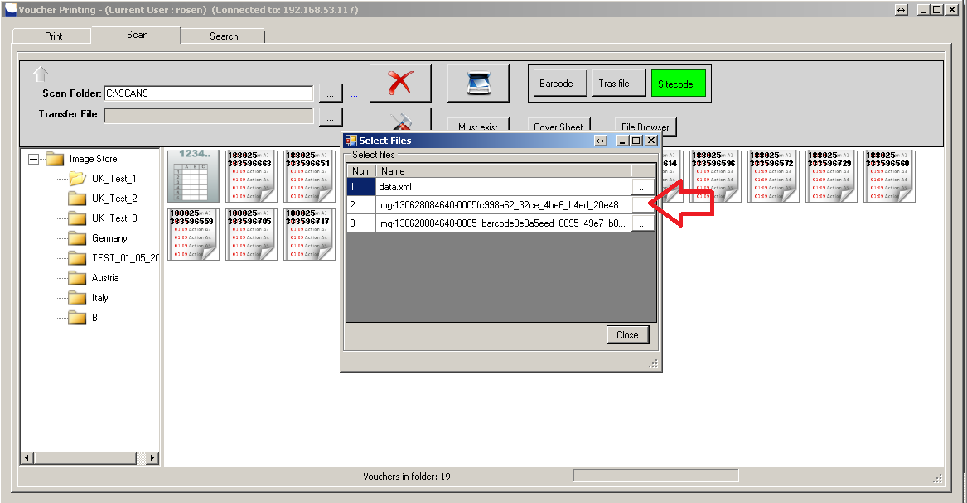Select the wanted one to see the content.

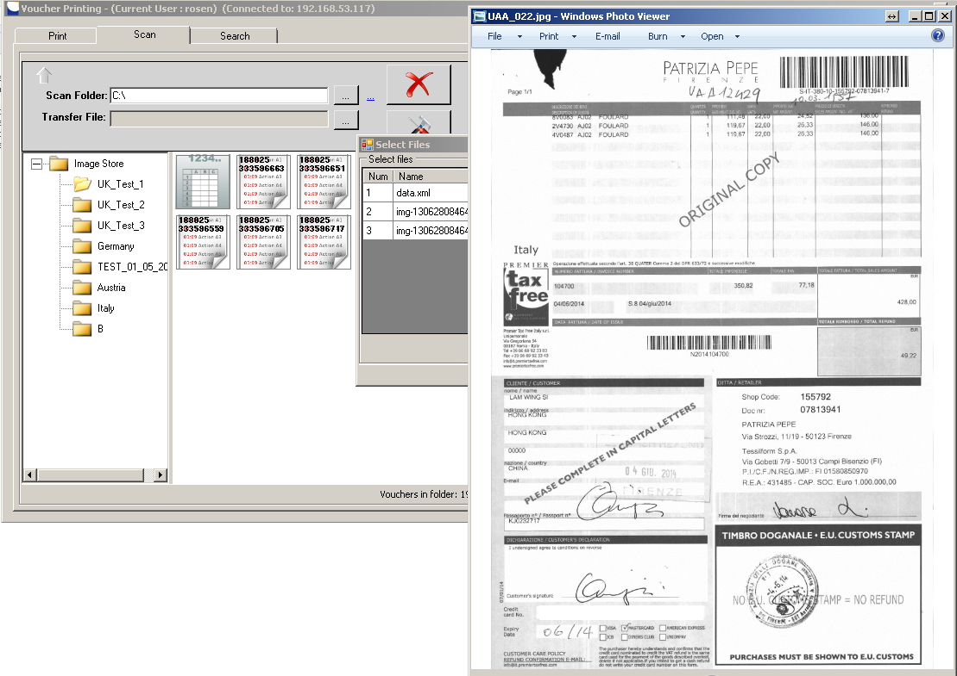

## SHOWING VOUCHER SIGNED

### How it works?

Point voucher, right click on it, and choose “Show” from drop down context menu. Select a file from “Show files” window.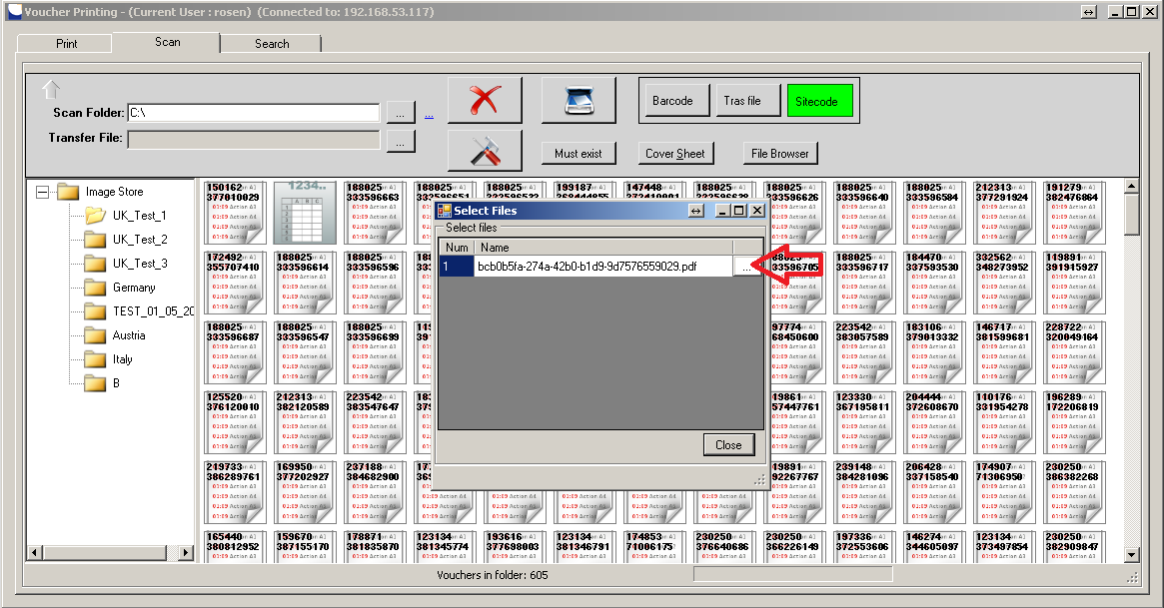

You’ll see the signed document

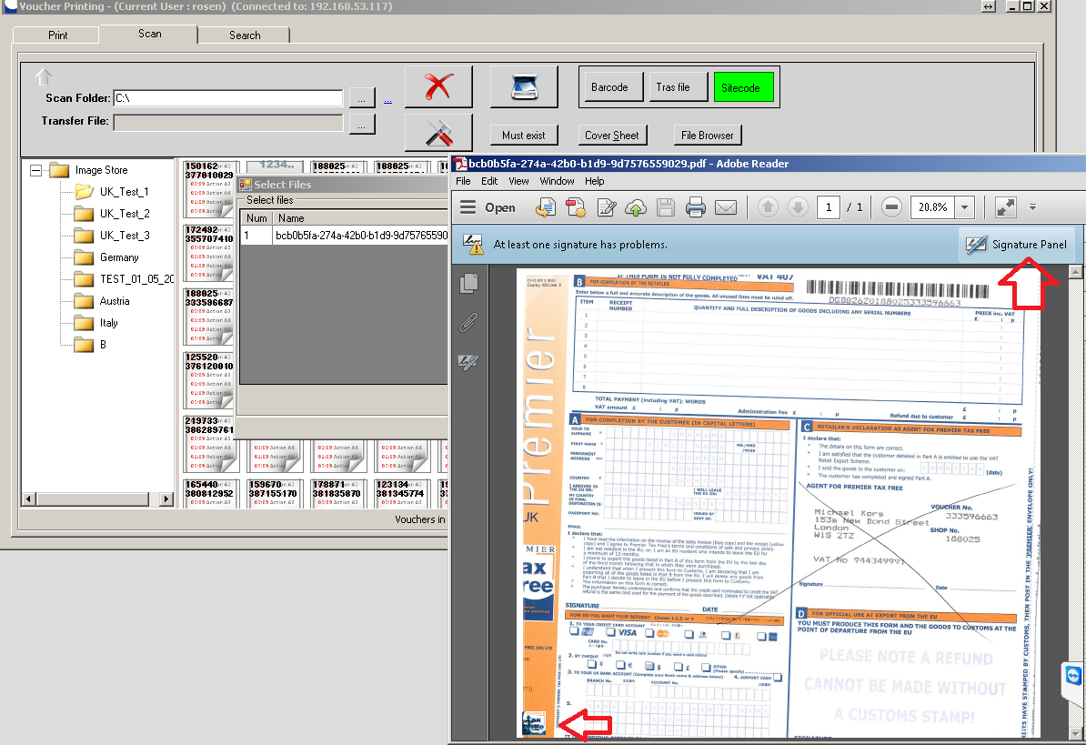

## NAMING VOUCHER

Naming vouchers is an option that allows operator to put images in the image store in order. Naming vouchers is not mandatory.

### How it works?

To name a voucher right click on it. Select “Rename” from drop down menu and enter a new name. Click “Ok” to confirm.

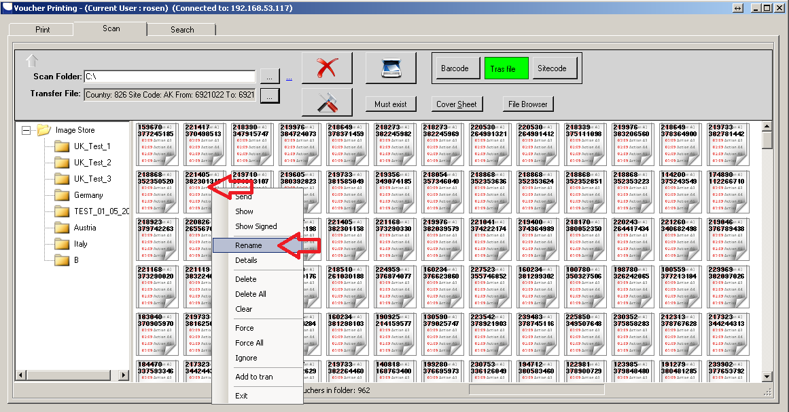

### Notes

##### Name of the voucher may by any alphanumeric sequence.

##### Name of the voucher many not exceed more than 50 characters.

## DELETE VOUCHER

### How it works?

Browse remote image store. Find the image needed right-click on it and select “Delete”. Application shows you confirmation window. Confirm you want to delete the image.

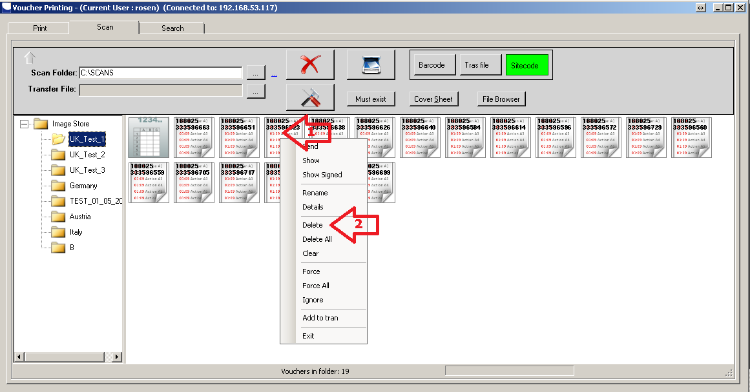

### Note

##### This operation cannot be undone.

## DELETE ALL VOUCERS IN FOLDER

### How it works?

Right click on any voucher in folder. From context menu select “Delete All”. Application shows you the confirmation screen. Confirm the operation.

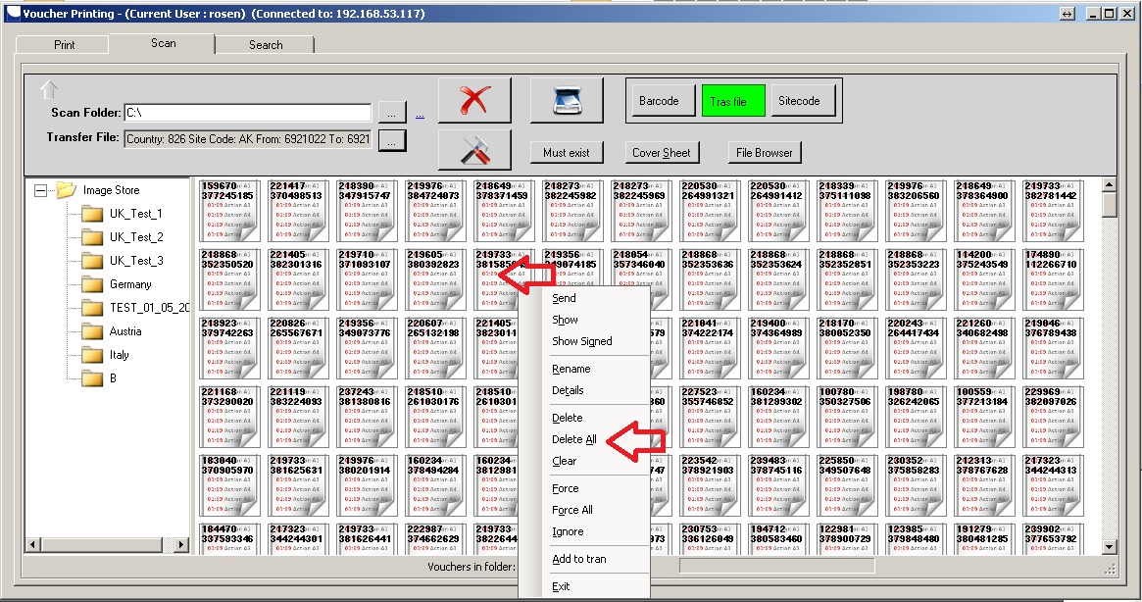

### Notes

##### Deleting signed vouchers is not allowed.

##### This operation cannot be undone.

## FORCE SENDING VOUCHER

### How it works?

Forcing items over communication channel make sure item is sent even if in case of fault or communication failure.

## FORCE SENDING ALL VOUCHERS

### How it works?

Forcing items over communication channel make sure items are sent even if in case of fault or communication failure. Forcing all the items should be avoided.

## IGNORE VOUCHER VALIDATION DURING SEND

### How it works?

During sending server verify all incoming data. Sometimes this could cause a problem. To avoid such scenarios use “Ignore “option.

### Note

Ignoring server validation should normally be avoided and not necessary.

# STEP 4: START SCANNING

## SCANNING MODES

### BY BARCODE

#### How it works?

Once the file dropped in local scan folder VPrint picked it. It searches for a barcode in image. Barcode contains codes country, retailer, voucher number. Application encodes the barcode info.

#### Prerequisites

##### Paper voucher must contain a barcode

##### Barcode should be clean and readable from the software

##### The barcode should be in some of company valid formats.

##### If barcode is not found or not valid the operator will need to enter the voucher details manually.

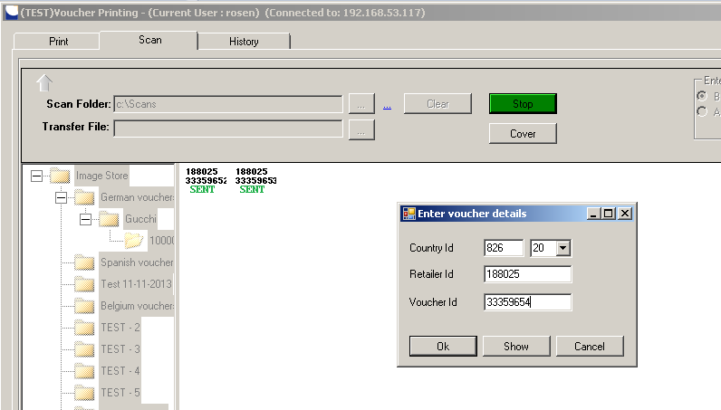

#### Performance

##### Scanning vouchers by barcode may not be quick for vouchers missing barcode image on them.

#### How to run it

To select a barcode mode click on the “Barcode” button.

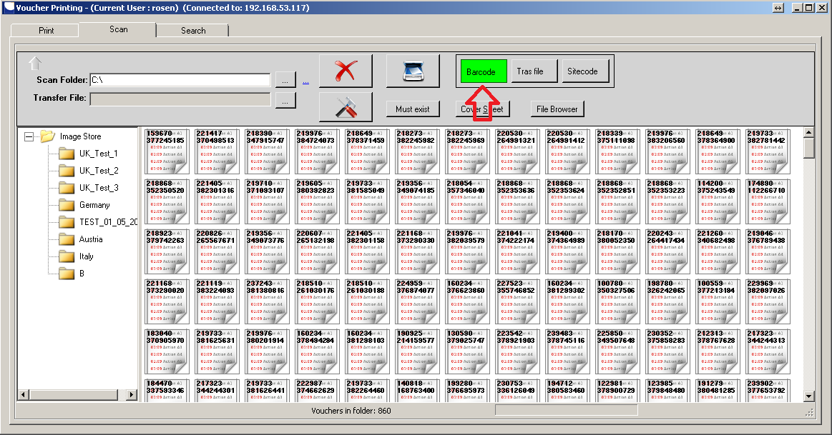

### BY TRANSFER FILE

#### How it works?

Transfer file is ordered sequence of vouchers. The order key is site code.

#### Prerequisites

##### Scanned vouchers should already be entered.

##### Paper vouchers should be order in same sequence.

#### Performance

Performance of scanning vouchers by Transfer file id very high, but operator needs to have paper vouchers ordered in same sequence initially. That may not be quick and time consuming, manual operation.

#### How to run it?

Start VPrint and click on the “Trans file” button.

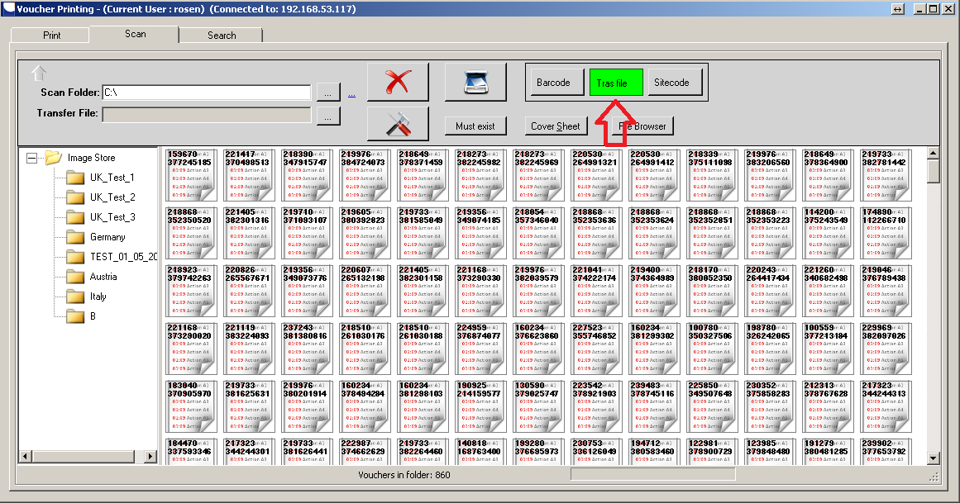

Click on the button next to transfer file text box and open “Transfer Form”. Click OK.

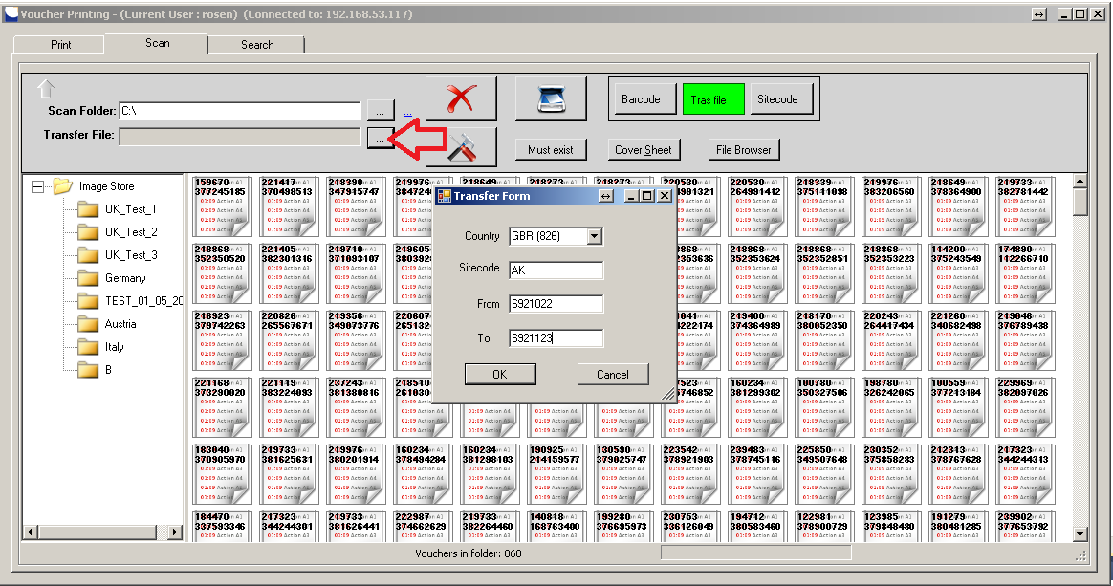

The system load voucher form initially with not committed items and is ready to start now.

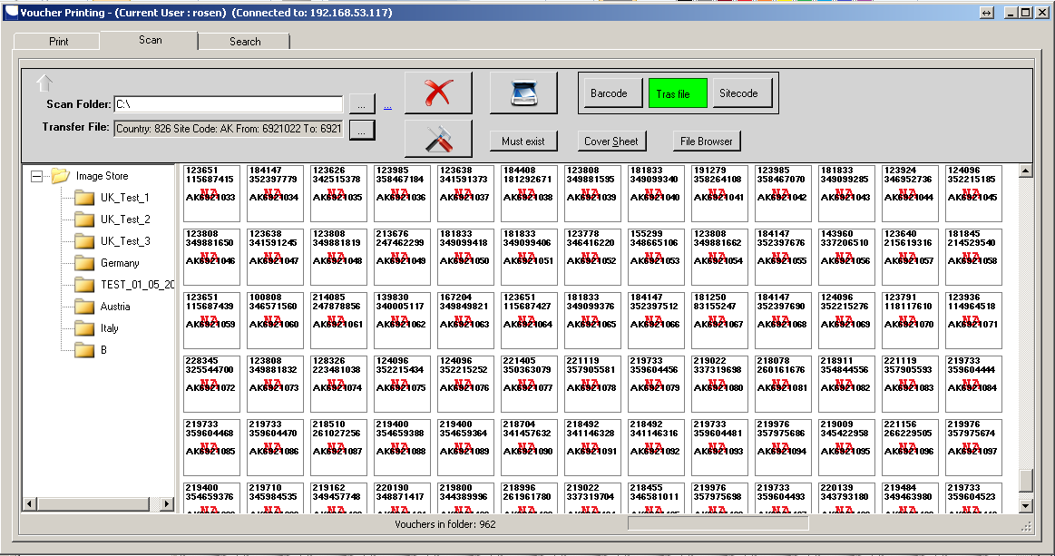

### BY SITECODE

#### How it works?

Scanning vouchers by site code gets site code number from name of file. System calls the central server to get more details about the voucher.

#### Prerequisites

##### Voucher must already be entered with TRS.

##### Name of file should corresponded site code of incoming voucher image.

#### Performance

Performance of the system is very high. Paper vouchers do not need to be ordered in a sequence initially.

#### Weaknesses

Number of server and database calls is higher.

# STEP 5: FILE BROWSING

In order importing already taken images system supports directory file browsing.

## How it works?

Operator browses folder structure. They find directory wanted and start “Copy file” process. Application copies all image files and processes those according selected mode.

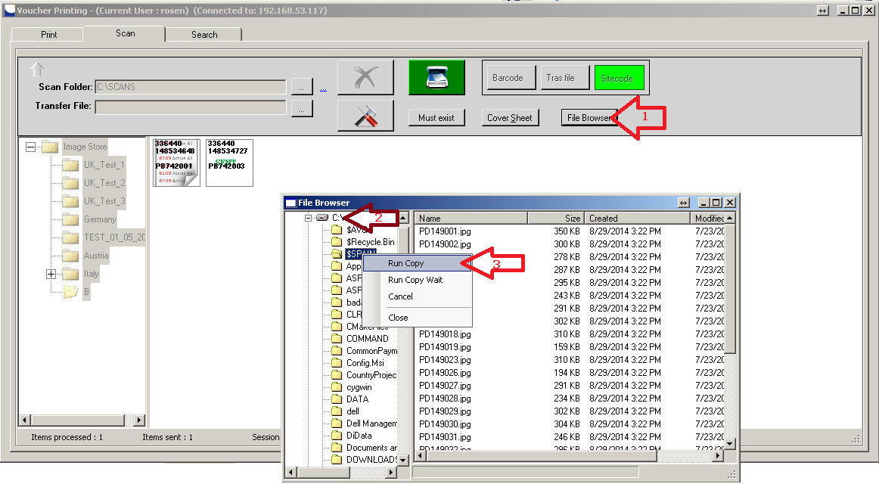

# STEP 6: SCANNING NON VOUCHER IMAGE FILES

## How it works?

System is capable of scanning any images. The system processes those without any validation and checks. Start scanning. Click on the “Cover Sheet” button. Scan any document; image goes straight away to the server. This button will switch off every time you scan.

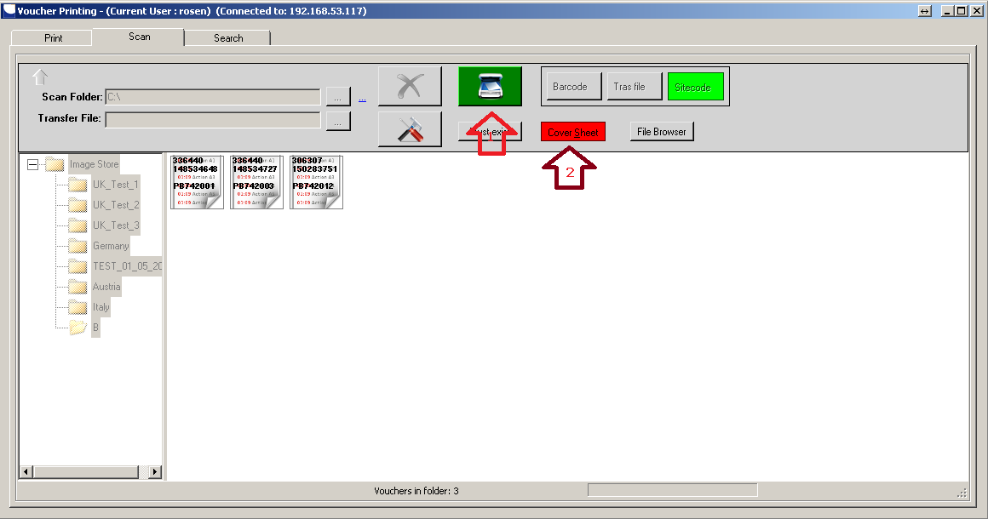

# STEP 7: MONITORING SCAN PROCESS

## How it works?

Using flatbed scanner requires operator staying beside the scanner. In this case he/she needs to see the process close. Click on the “Monitor” button to visualize the process monitor window.

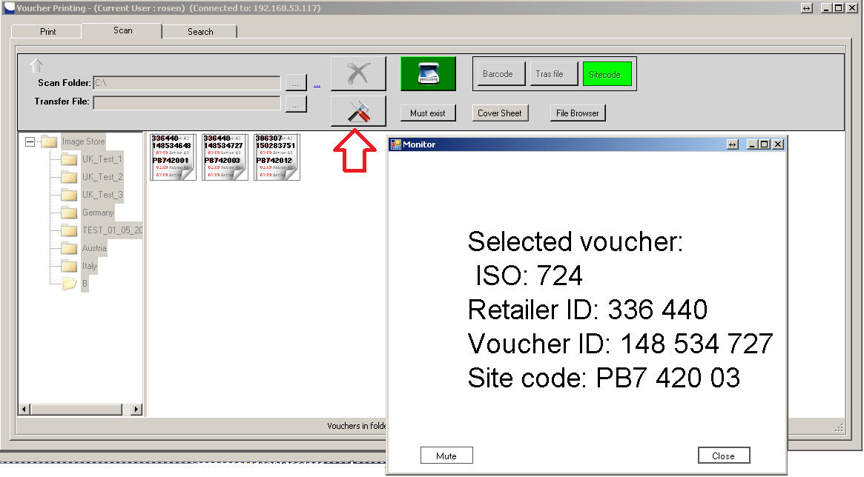

# STEP 8: SEARCHING FOR A VOUCHER

## How it works?

Open the search tab by clicking search tab header. Enter any country, retailer, voucher number or voucher date and click the on the “Search” button. According to the filter vouchers appear in the grid below. Choose one and right click on it. Select “Show” option.

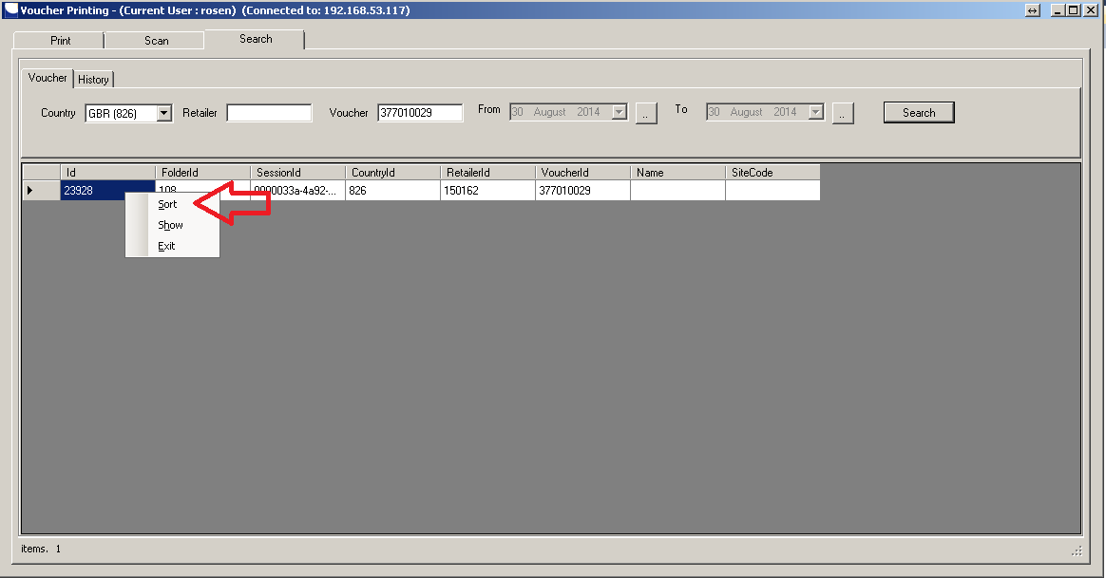

It shows you a list of all files included. Select the one you want to see and click on the bottom. The system uses the default Windows viewer to open the file.

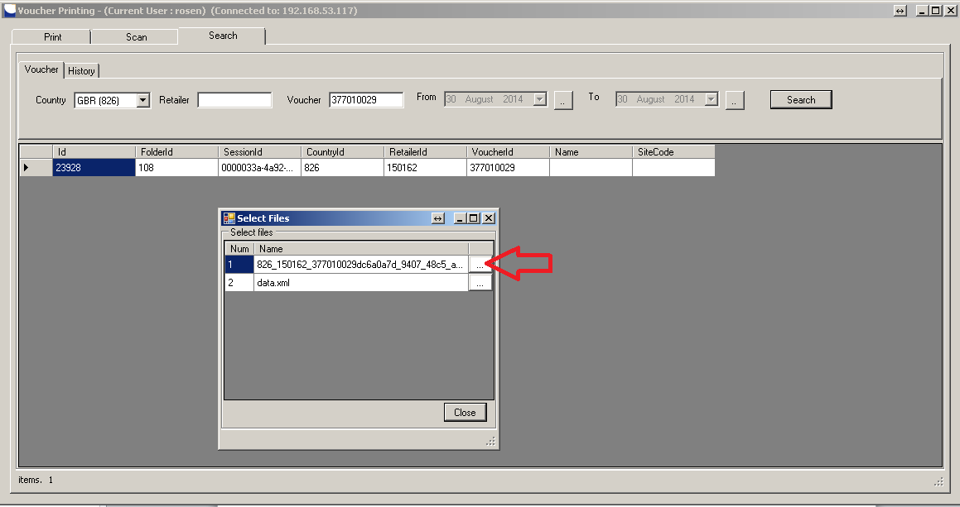

# STEP 9: SHOWING HISTORY

## How it works?

Open the history tab by clicking the history header. Enter details in filter and click on search. The system shows you a list of all activities meeting the search filter.  
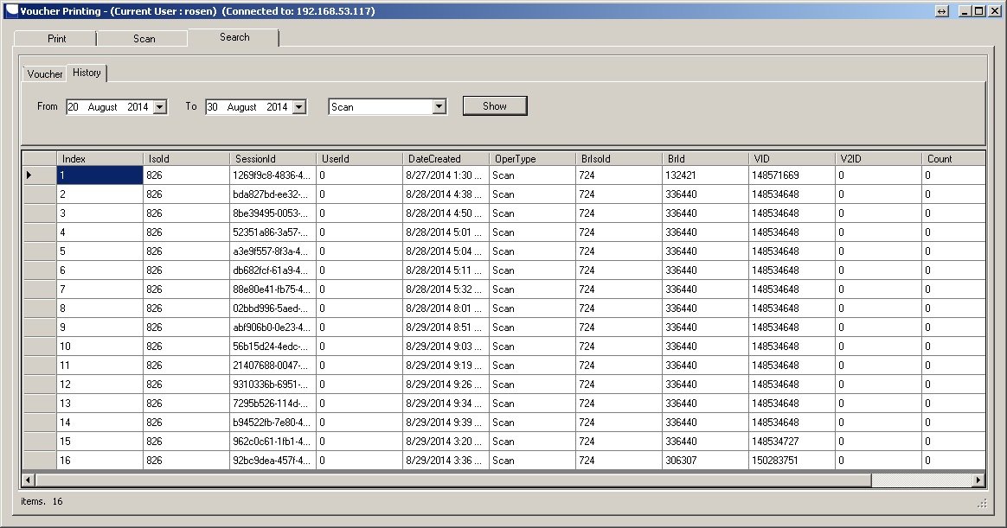

# Thank you!